# FEM achterbrug/FEM suspension

## Loadcases en maten/Load cases and measurements

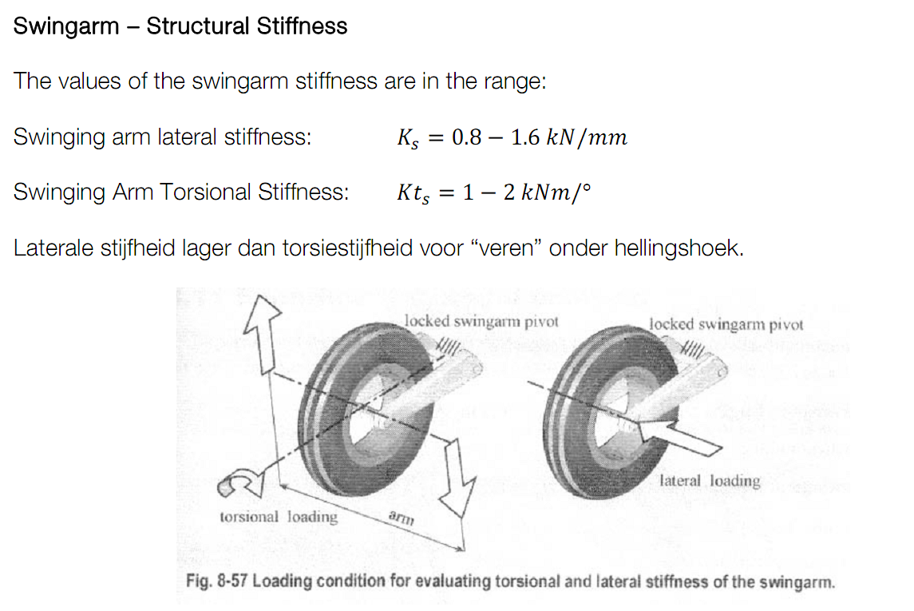

Lateral stiffness lower than torsional stiffness for springs under an angle.   
Source: Motorcycle Dynamics, page 335

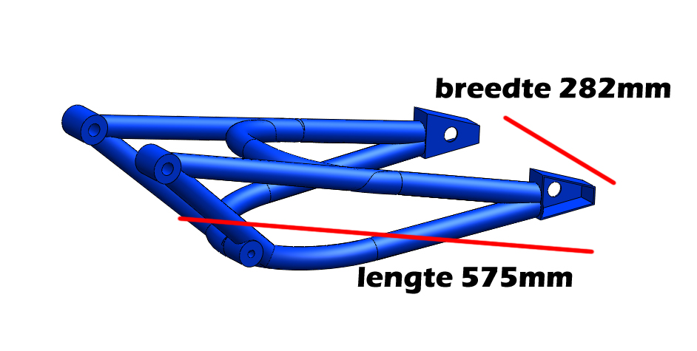

Lateraal achterbrug/Lateral swingarm

 Length swingarm



 0.1% of the swingarm deviation



 N/mm -> lower range of the lateral stiffness by Cossalter



 N/mm -> upper range of the lateral stiffness by Cossalter



 0.1% of the swingarm length of deviation*stiffness = Force/Load



 0.1% of the swingarm length of deviation *stiffness = Force/Load

|  |  |  |
| --- | --- | --- |
| Buiging achterbrug lateraal/ Lateral bending swingarm | | |
| Source | Value (kN/mm) | Load (N) |
| Cossalter | 0,8 | 460 |
| Cossalter | 1,6 | 920 |



Torsie Achterbrug/Torsion swingarm

 ?



 mm









 How is this a force?



 N/mm -> lower bound torsional stiffness Cossalter



 N/mm -> upper bound torsional stiffness Cossalter



 N/mm -> Aprilia rs250



 N/mm -> Desmo RR



 N/mm -> Ducati 999



 N -> Computes load from Fn*Stiffness

|  |  |  |  |
| --- | --- | --- | --- |
| Torsiestijfheid achterbrug/Torsional stiffness swingarm | | | |
| Source | Motorcycle | Torsional Stiffness (kNm/degree) | load (N) |
| Cossalter | Range metingen | 1 | 1773 |
| Cossalter | Range metingen | 2 | 3546 |
| Bradley | Aprilia rs250 | 1,6 | 2837 |
| web | Ducati desmo RR | 1,5 | 2660 |
| web | Ducati 999 | 1,1 | 1950 |





















**verplaatsing achterbrug naar hoek, 1:400N (cossalter lateraal 1); 1. 2:800N (cossalter lateraal 2); 2.1;1773N (cossalter torsie 1); 2.2:3546N (cossalter torsie 2); 3:2837N (rs250); 4:2660N (desmo RR);** **5:1951N (999)**

**Move suspension to an angle? For the different values of torsional stiffness and loads.**

 ?



 translated value lower bound lateral stiffness Cossalter



 translated value upper bound lateral stiffness Cossalter



 translated value lower value torsional stiffness Cossalter



 translated value upper bound torsional stiffness Cossalter



 translated value Aprilia RS250



 translated value Desmo RR



 translated value Ducati 999



 -> Compute and translate to degrees



















# Resultaten FEM/Results FEM

*These tests will need to be done for our design for the swingarm.*

**Lateraal Cossalter range @ 460N Lateraal Cossalter range @ 920N**

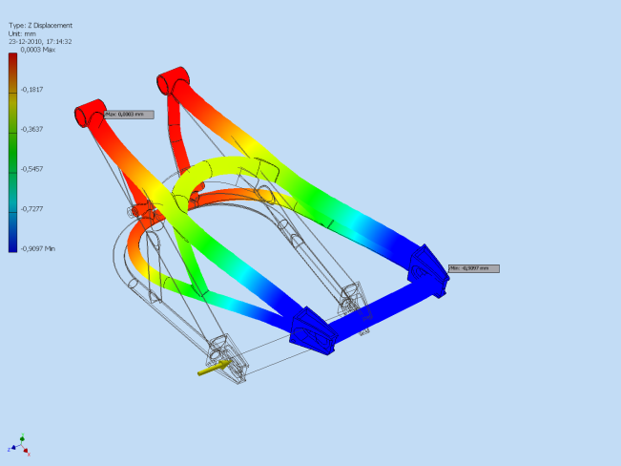 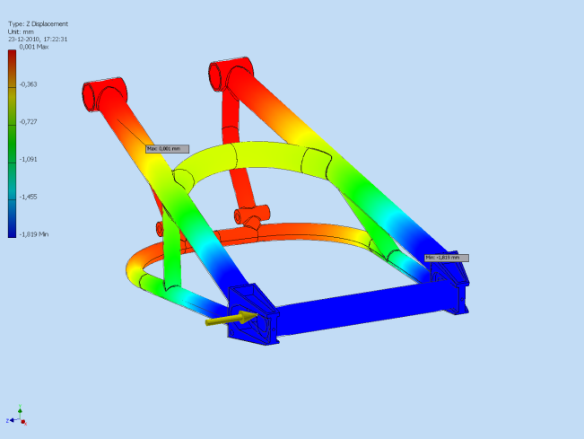

**Torsie Cossalter range @ 1773N Torsie Cossalter range @ 3546**

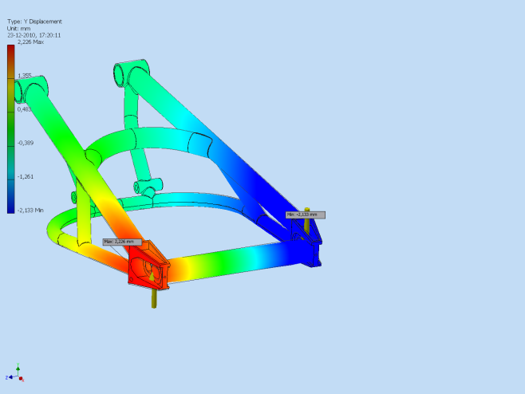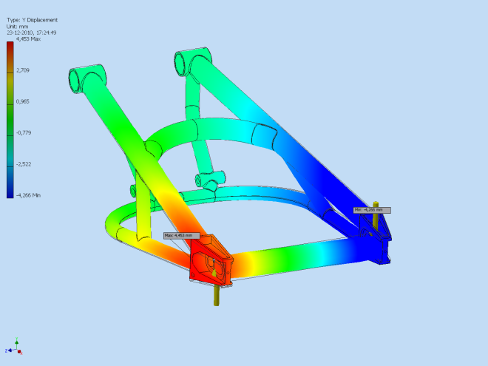

**Torsie Aprilia RS250 waarde Bradley @ 2837N Torsie Ducati desmo RR @ 2660N**

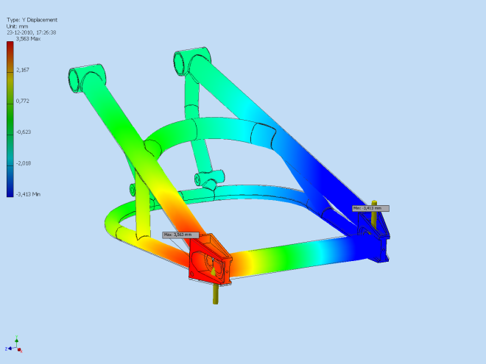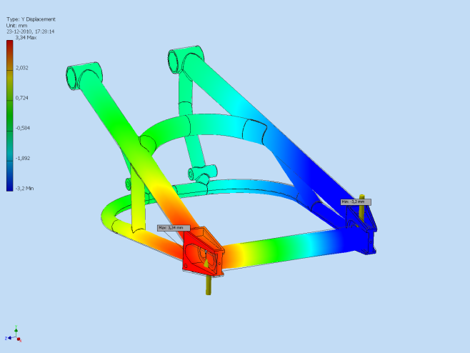

**Torsie Ducati 999 @ 1950N**

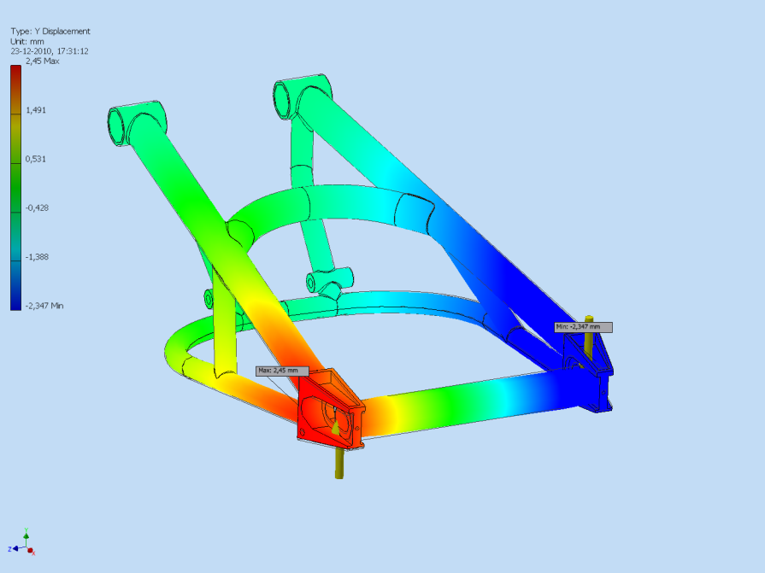

|  |  |
| --- | --- |
| Resultaten buiging lateraal/ Results lateral bending | |
| Source | Uitwijking/displacement(mm) |
| Cossalter | 0,9 |
| Cossalter | 1,8 |

|  |  |  |
| --- | --- | --- |
| Resultaten torsiestijfheid achterbrug/ Torsional stiffness swingarm | | |
| Source | Uitwijking/displacement (mm) | uitkomst (graad)/(degrees) |
| Cossalter | 2,2 | 0,894 |
| Cossalter | 4,45 | 1,81 |
| Bradley | 3,56 | 1,44 |
| web | 3,34 | 1,36 |
| web | 2,45 | 0,995 |

## Conclusie

De achterbrug zoals ontworpen door Wido en doorgerekend door Yoeri, blijkt binnen de ranges te vallen qua laterale buiging (maximaal 1mm) en torsiestijfheid (maximaal 1 graad). De iteratiestappen die hiervoor zijn gedaan is dat de ligger naar 34.9mm is gezet en de buis die de ligger en brace verbind onder een andere hoek te plaatsen, waardoor de stijfheidseisen worden gehaald. Een opzienbarende conclusie is dat blijkt dat de achterbrug zoals ontworpen nagenoeg, op 5 duizendste graad na, torsiestijf is als de achterbrug van de Ducati 999. In de FEM-resultaten zijn de aangrijppunten van de krachten te zien.

The swingarm as designed by Wido and calculated by Yoeri, is within the ranges in terms of lateral bending (max 1mm) and torsional stiffness (max 1 degree). The iteration steps that have been done are the ‘ligger’ is moved to 34.9mm and the tube that connects the ‘ligger’ and the brace is placed under a different angle. Because of this the stiffness requirements are met. An interesting conclusion is that the designed swingarm is, on 5 thousands of a degree, equal in terms of torsional stiffness to the swingarm of the Ducati 999. In de FEM-results the effective points of the forces can be seen.